ShowTime
Business Report

Predictive Modelling Coded Project
By
Rajesh Mambulli

Context
An over-the-top (OTT) media service is a media service offered directly to viewers via the internet. The term is most synonymous with subscription-based video-on-demand services that offer access to film and television content, including existing series acquired from other producers, as well as original content produced specifically for the service. They are typically accessed via websites on personal computers, apps on smartphones and tablets, or televisions with integrated Smart TV platforms.

Presently, OTT services are at a relatively nascent stage and are widely accepted as a trending technology across the globe. With the increasing change in customers' social behaviour, which is shifting from traditional subscriptions to broadcasting services and OTT on-demand video and music subscriptions every year, OTT streaming is expected to grow at a very fast pace. The global OTT market size was valued at $121.61 billion in 2019 and is projected to reach $1,039.03 billion by 2027, growing at a CAGR of 29.4% from 2020 to 2027. The shift from television to OTT services for entertainment is driven by benefits such as on-demand services, ease of access, and access to better networks and digital connectivity.

With the outbreak of COVID19, OTT services are striving to meet the growing entertainment appetite of viewers, with some platforms already experiencing a 46% increase in consumption and subscriber count as viewers seek fresh content. With innovations and advanced transformations, which will enable the customers to access everything they want in a single space, OTT platforms across the world are expected to increasingly attract subscribers on a concurrent basis.

Objective
ShowTime is an OTT service provider and offers a wide variety of content (movies, web shows, etc.) for its users. They want to determine the driver variables for first-day content viewership so that they can take necessary measures to improve the viewership of the content on their platform. Some of the reasons for the decline in viewership of content would be the decline in the number of people coming to the platform, decreased marketing spends, content timing clashes, weekends, and holidays, etc. They have hired you as a Data Scientist, shared the data of the current content in their platform, and asked you to analyse the data and come up with a linear regression model to determine the driving factors for first-day viewership.

Data Description
The data contains the different factors to analyse for the content. The detailed data dictionary is given below.

Data Dictionary:
- visitors: Average number of visitors, in millions, to the platform in the past week
- ad_impressions: Number of ad impressions, in millions, across all ad campaigns for the content (running and completed)
- major_sports_event: Any major sports event on the day
- genre: Genre of the content
- dayofweek: Day of the release of the content
- season: Season of the release of the content
- views_trailer: Number of views, in millions, of the content trailer
- views_content: Number of first-day views, in millions, of the content

Data Overview through Python
Data which is stored in csv file is imported to Jupyter Notebook with the help of pandas, NumPy libraries and used matplotlib and seaborn libraries to help with data visualization. Dataset is stored in python variable named data.

Understanding the shape of the dataset.
This dataset contains 1000 rows and 8 columns.
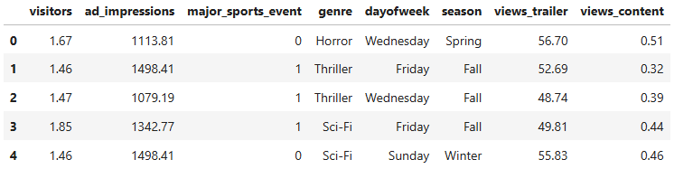

Checking the data types of data.
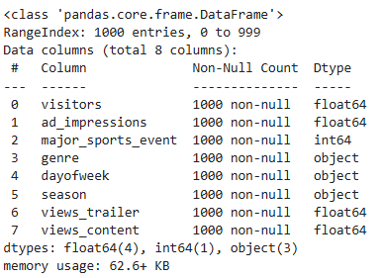
All the Numerical attributes are in either int or float datatype which is desired. And remaining categories are string object type.
This concludes there is no need to change the data types of any attributes listed in the dataset.

Checking for missing values in the data.
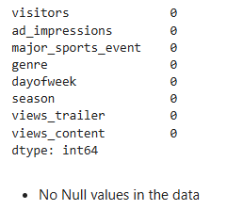

Checking for duplicate values in the data.


Checking the statistical summary of the numerical data.

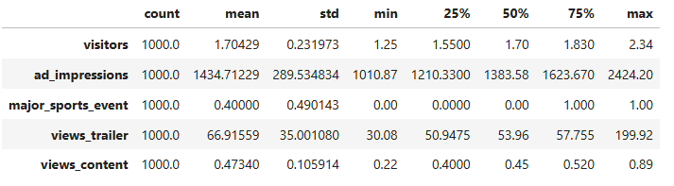
Visitors
The dataset consists of 1000 entries with the number of visitors. On average, there are approximately 1.704 visitors, with a standard deviation of 0.232. The minimum number of visitors recorded is 1.25, and the maximum is 2.34. The data is fairly cantered around 1.7, as evidenced by the median value.

Ad Impressions
This dataset shows the number of ad impressions with a mean value of 1434.71 and a standard deviation of 289.53. This suggests that while most impressions are around the average, there is a considerable spread. The minimum number of impressions is 1010.87, while the highest reaches 2424.20. Quartiles indicate that 25% of the data falls below 1210.33, and 75% falls below 1623.67.
Major Sports Event
This categorical variable indicates whether a major sports event is taking place. The mean value of 0.40, combined with a standard deviation of 0.49, suggests that sports events occur less frequently than not. The minimum and median values are 0, while the maximum is 1, indicating some instances of such events.
Views Trailer
The number of trailer views averages 66.92, with a standard deviation of 35.00, which shows high variability. The dataset ranges from 30.08 to 199.92 views. The lower quartile is around 50.95, and the upper quartile is approximately 57.76, indicating that most of the data is concentrated between these values.
Views Content
For views of the main content, the average value is 0.47 with a standard deviation of 0.11, The minimum value is 0.22 and the maximum is 0.89, with the median at 0.45. Quartiles indicate that 25% of the data is below 0.40 and 75% is below 0.52.

